**Analyzing the effects of Indigenous Activity Intervention to reduce the Cardiovascular Disease Risk of the School Children**

**1Assistant Professor, Govt. College of Physical Education for Women, Dinhata, Cooch Behar. Email-** [**anirpanfootbal@gmail.com**](mailto:anirpanfootbal@gmail.com) **Ph. No.: 8004554806**

**2Associate Professor, Rabindra Mahavidyalaya Champadanga, Hoogly. Email-** [**atanupe@rediffmail.com**](mailto:atanupe@rediffmail.com)

**3Principal, Govt. College of Physical Education for Women, Dinhata, Cooch Behar. Email-** [**2010badshahghosh@gmail.com**](mailto:2010badshahghosh@gmail.com)

**Abstract:**

***Introduction:***

The global health community is increasingly concerned about childhood obesity and cardiovascular issues. A high resting heart rate (RHR) in young individuals predicts future heart-related risks. Regular exercise can reduce RHR by improving cardiovascular fitness and autonomic nervous system function. The Indigenous Activity Intervention (IAI), incorporating culturally appropriate exercises, has shown potential in promoting physical activity among indigenous groups. However, research on IAI's specific impact on RHR in school-age children is lacking. This study examines the effects of a 10-week IAI program on RHR in males aged 12-14. Understanding IAI's impact on RHR could inform public health initiatives and school-based exercise programs to reduce cardiovascular disease risks in youth. This research addresses a significant gap and has implications for policies promoting heart health through culturally sensitive physical activity programs.

***Methods:***

The study used a randomized controlled trial methodology, with the test group participating in structured IAI and the control group receiving no intervention. The IAI included six indigenous activities, conducted four times weekly for 50-60 minutes per session. The study focused on sedentary male students (n=120) aged 12-14.

***Results:***

The results indicated a statistically significant relationship between the IA training program and RHR, as evidenced by the significant F-value [F (1,117) = 214.597, p < .05]. The eta squared score of 0.647 suggested that approximately 64.7% of the variance in RHR could be attributed to the IAI.

***Conclusion:***

This research enhances our understanding of structured IAI’s effects on cardiovascular health in school-aged children. The results suggest that such programs can effectively lower RHR through physiological changes, highlighting their potential importance in promoting cardiovascular fitness among youth.

**Introduction**

Cardiovascular health issues and childhood obesity are worldwide concerns. Elevated resting heart rate (RHR) in children is associated with future cardiovascular risks. RHR serves as a crucial indicator of cardiovascular health and fitness, particularly in young individuals. Lower RHR values generally indicate better cardiac function and overall fitness levels, making it an essential metric in pediatric health assessments (Pierpont et al., 2000; Levine et al., 1990). Regular physical activity has been shown to positively influence RHR by improving autonomic nervous system function and cardiac efficiency, thereby reducing heart strain at rest (Warburton et al., 2006; Rognmo et al., 2004). While extensive research has been conducted on various forms of physical training, the potential benefits of Indigenous Activity (IA) interventions – traditional games and activities – on children's cardiovascular health remain understudied.

This study aims to analyze the resting heart rates of schoolchildren aged 12 to 14 in relation to a 10-week Indigenous Activity intervention. The intervention utilizes culturally relevant and physically demanding activities to encourage participants to adhere to a regular exercise regimen and improve their cardiovascular health.

**Methodology**

***Procedure:***

A physical fitness assessment was conducted in the Cooch Behar region of West Bengal, India, involving 212 students from two prominent boys' schools. The study focused on pupils aged 12 to under 14. The Ministry of Youth Affairs and Sports established an Expert Committee to define fitness benchmarks, enabling students to complete the program. Based on these benchmarks, 120 students scoring in level 3 and level 4 categories were included in the analysis, suggesting their potential to complete the IA training program. Following the Pre-Post Random Group Design, participants were equally divided into an Experimental Group (N = 60) and a Control Group (N = 60). The investigation consisted of pre-testing and post-testing phases. To gather Pre-Test data for RHR, children were asked to rest in a chair for 5 minutes in a designated school classroom. RHR measurements were taken from the right Radial Artery (Beats per Minute), with two readings obtained at one-minute intervals and their average used for analysis. Between pre- and post-tests, only the experimental group followed the Training Protocol of Indigenous Activities, which included six popular native activities. The researcher developed this protocol based on a detailed pilot study with subjects of similar age and guidance from renowned Physical Education Experts.

***Ten Weeks Indigenous Activity Training Protocol***

*Total no. of Indigenous activities*= **Six.**

*Name of the activities* : **Kit-kit, Golla-Chhut, Chhi-Buri, Pakki, Edur-Biral, Rumal Churi**.

|  |  |  |  |
| --- | --- | --- | --- |
| 1st and 2nd Week | Days | Activity | Division |
| 1st day | Kit-kit, Golla-Chhut. | 5 min. warm up, 40 min. indigenous activity, 5 min cooling down. |
| 2nd day | Chhi-Buri, Pakki. | 5 min. warm up, 40 min. indigenous activity, 5 min cooling down. |
| 3rd Day | Kit-kit, Chhi-Buri, | 5 min. warm up, 40 min. indigenous activity, 5 min cooling down. |
| 4th Day | Golla-Chhut, Pakki. | 5 min. warm up, 40 min. indigenous activity, 5 min cooling down. |
| 3rd and 4th Week | 1st day | Kit-kit, Golla-Chhut | 5 min. warm up, 50 min. indigenous activity, 5 min cooling down. |
| 2nd day | Chhi-Buri, Pakki. | 5 min. warm up, 50 min. indigenous activity, 5 min cooling down |
| 3rd day | Kit-kit, Chhi-Buri, | 5 min. warm up, 50 min. indigenous activity, 5 min cooling down |
| 4th day | Golla-Chhut, Pakki. | 5 min. warm up, 50 min. indigenous activity, 5 min cooling down |
| 5th and 6th week | 1st day | Kit-kit, Golla-Chhut, Pakki. | 5 min. warm up, 50 min. indigenous activity, 5 min cooling down |
| 2nd day | Chhi-Buri, Pakki, Kit- kit. | 5 min. warm up, 50 min. indigenous activity, 5 min cooling down |
| 3rd day | Kit-kit, Golla-chhut Pakki, | 5 min. warm up, 50 min. indigenous activity, 5 min cooling down |
| 4th day | Golla-Chhut, Pakki, Chhi-Buri. | 5 min. warm up, 50 min. indigenous activity, 5 min cooling down |
| 7th & 8th week | 1st day | Kit-kit, Golla-Chhut, Pakki, Rumal Churi. | 5 min. warm up, 50 min. indigenous activity, 5 min cooling down |
| 2nd day | Chhi-Buri, Pakki, Rumal Churi, Golla-Chhut. | 5 min. warm up, 50 min. indigenous activity, 5 min cooling down. |
| 3rd day | Kit-kit, Golla-chhut Pakki, Rumal Churi. | 5 min. warm up, 50 min. indigenous activity, 5 min cooling down. |
| 4th day | Golla-Chhut, Pakki, Chhi-Buri, Kit-Kit. | 5 min. warm up, 50 min. indigenous activity, 5 min cooling down. |
| 9th & 10th Week | 1st day | Kit-kit, Golla-Chhut, Pakki, Edur-Biral, Rumal Churi. | 5 min. warm up, 50 min. indigenous activity, 5 min cooling down |
| 2nd day | Chhi-Buri, Pakki, Kit- kit, Edur-Biral, Rumal Churi. | 5 min. warm up, 50 min. indigenous activity, 5 min cooling down. |
| 3rd day | Golla-chhut Pakki, Chhi-Buri, Edur-Biral, Rumal Churi. | 5 min. warm up, 50 min. indigenous activity, 5 min cooling down. |
| 4th day | Golla-Chhut, Kit-Kit, Chhi-Buri, Edur-Biral, Rumal Churi. | 5 min. warm up, 50 min. indigenous activity, 5 min cooling down. |

**Analysis of Data:**

After the completion of ten weeks of training program anxiety level of both the groups was again measured and the collected data were analysed by using the IBM SPSS version 20. A one way analysis of covariance (ANCOVA) was conducted to compare the effects of IA on Post-test result of the Experimental (Mean= 61.83, SD=±3.34) and control Groups (Mean= 67.8, SD= ± 3.45) While controlling the Pre-test data as covariate. Shapiro-Wilk test and Levene’s test was conducted to meet the assumptions.

**Result:**

There was a significant difference between Control and Experimental group [F (1,117)= 214.597, p=<.05] (Table 1). A Post hoc test showed there was a significant difference in between Resting Heart Rate of both groups. The partial Eta Squared value indicates the effect size and were compared with the Cohen’s guideline (0.2 = Small effect, 0.5 = Moderate effect, 0.8= Large effect). According to that for both groups the effect size is moderate and near to large (0. 647). The Partial Eta Squared value showed the 64.7% of variance in Resting Heart Rate of both groups when controlling the Pre-test Resting Heart Rate.

|  |  |  |  |  |  |  |
| --- | --- | --- | --- | --- | --- | --- |
|  | | | | | | |
|  | | | | | | |
|  | Sum of Squares | df | Mean Square | F | Sig. | Partial Eta Squared |
| Contrast | 1091.434 | 1 | 1091.434 | 214.597 | .000 | .647 |
| Error | 595.057 | 117 | 5.086 |  |  |  |
|  | | | | | | |

Table 2 shows the results of the Levene’s Test is insignificant (p= >0.05), indicating that the group variances are equal. Hence, the assumption of homogeneity of variances was not violated.

|  |  |  |  |
| --- | --- | --- | --- |
|  | | | |
|  | | | |
| F | df1 | df2 | Sig. |
| 3.267 | 1 | 118 | .073 |
|  | | | |
|  | | | |

The normality of the data was tested by the Shapiro-wilk formal test. Table 3 shows the insignificant (p= >0.05), indicating the data were normally distributed. Also both Q-Q plot shows the same result.

|  |  |  |  |  |  |  |
| --- | --- | --- | --- | --- | --- | --- |
| **Tests of Normality** | | | | | | |
|  | Kolmogorov-Smirnova | | | Shapiro-Wilk | | |
| Statistic | df | Sig. | Statistic | df | Sig. |
| RHRpost | .058 | 120 | .200* | .992 | 120 | .674 |
| RHRpre | .098 | 120 | .007 | .985 | 120 | .220 |

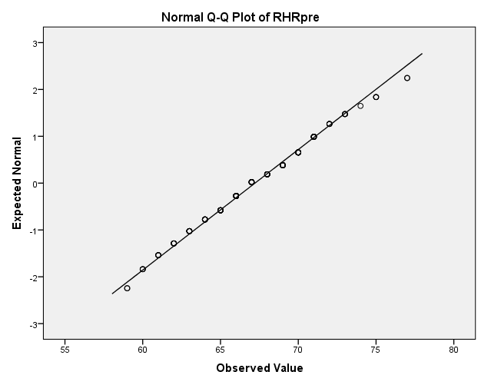 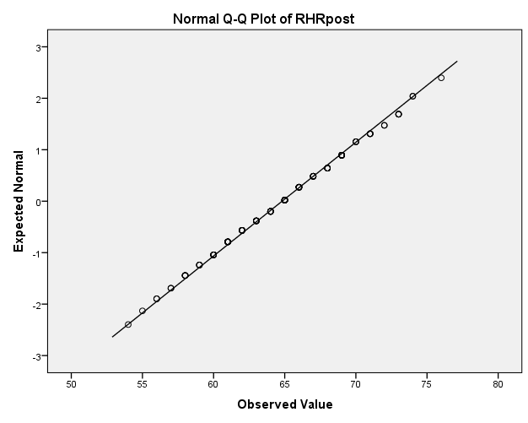

**Discussion:**

This research investigated the impact of a 10-week exercise regimen on the resting heart rates of children between 12 and 14 years old. The analysis revealed a statistically significant correlation between the IA training program and participants' Resting Heart Rate, as evidenced by the F-value [F (1,117)= 214.597, p= <.05]. The eta squared value of 0.647 indicates that the IA program accounted for roughly 64.7% of the variation in Resting Heart Rate.

Research by Warburton et al. (2006) shows that exercise training enhances stroke volume, allowing the heart to pump more blood per beat, which gradually reduces resting heart rate (RHR). Pierpont et al. (2000) found that regular exercise decreases RHR by boosting parasympathetic tone and reducing sympathetic activity. According to Rognmo et al. (2004), exercise stimulates the release of hormones such as adrenaline, initially increasing heart rate but ultimately improving metabolic efficiency and lowering baseline hormone levels and RHR. Levine et al. (1990) noted that improved cardiac efficiency diminishes the need for frequent heartbeats to circulate blood, resulting in a lower RHR. Combining high-intensity interval training (HIIT) with moderate-intensity continuous exercise improves the autonomic nervous system function in football players, balancing parasympathetic and sympathetic activity. Combining high-intensity interval training (HIIT) with moderate-intensity continuous exercise improves the autonomic nervous system function in football players. This combination balances parasympathetic and sympathetic activity, resulting in a lower resting heart rate (RHR) (Plews, D. J. et al, 2013). Football exercise improves overall fitness and body composition by enhancing cardiovascular performance, reducing body fat, increasing lean muscle mass, and lowering resting heart rate (Wisloff et al., 2007). However, Bahrainy et al. suggest that the decrease in RHR following regular exercise may not be solely due to increased parasympathetic tone or a reduction in the beta-adrenergic response and potential increase in parasympathetic output (Bahrainy, S., et al,2016). In this study, we observed a gradual decrease in RHR levels among the children who participated in the training program.

**Conclusion**

Based on a 10-week Indigenous Activity (IA) intervention plan, this study provides compelling evidence that children aged 12 to 14 can significantly lower their resting heart rate (RHR). The results show that children's cardiovascular efficiency and general fitness can be enhanced by culturally appropriate physical activities when they are routinely performed. The noteworthy decrease in RHR noted in the experimental group in contrast to the control group highlights the potential of Indigenous Activities to function as a useful instrument for improving the health of children.

**References**

Warburton, D. E., Nicol, C. W., & Bredin, S. S. (2006). Health benefits of physical activity: the evidence. Canadian Medical Association Journal, 174(6), 801-809.

Pierpont, G. L., Stolpman, D. R., Gornick, C. C., & Greenfield, R. A. (2000). Heart rate recovery post-exercise as an index of parasympathetic activity. Journal of the Autonomic Nervous System, 80(3), 169-174.

Rognmo, Ø., Hetland, E., Helgerud, J., Hoff, J., & Slørdahl, S. A. (2004). High intensity aerobic interval exercise is superior to moderate intensity exercise for increasing aerobic capacity in patients with coronary artery disease. European Journal of Cardiovascular Prevention & Rehabilitation, 11(3), 216-222.

Levine, B. D., Lane, L. D., Buckey, J. C., Friedman, D. B., & Blomqvist, C. G. (1990). Left ventricular pressure-volume and Frank-Starling relations in endurance athletes. Implications for orthostatic tolerance and exercise performance. Circulation, 81(2), 915-921.

Plews, D. J., Laursen, P. B., Stanley, J., Kilding, A. E., & Buchheit, M. (2013). Training adaptation and heart rate variability in elite endurance athletes: opening the door to effective monitoring. *Sports medicine*, *43*, 773-781.

Wisløff, U., Støylen, A., Loennechen, J. P., Bruvold, M., Rognmo, Ø., Haram, P. M., ... & Skjærpe, T. (2007). Superior cardiovascular effect of aerobic interval training versus moderate continuous training in heart failure patients: a randomized study. *Circulation*, *115*(24), 3086-3094.

Bahrainy, S., Levy, W. C., Busey, J. M., Caldwell, J. H., & Stratton, J. R. (2016). Exercise training bradycardia is largely explained by reduced intrinsic heart rate. *International journal of cardiology*, *222*, 213-216.

Warburton, D. E., Nicol, C. W., & Bredin, S. S. (2006). Health benefits of physical activity: the evidence. Canadian Medical Association Journal, 174(6), 801-809.

Pierpont, G. L., Stolpman, D. R., Gornick, C. C., & Greenfield, R. A. (2000). Heart rate recovery post-exercise as an index of parasympathetic activity. Journal of the Autonomic Nervous System, 80(3), 169-174.

Rognmo, Ø., Hetland, E., Helgerud, J., Hoff, J., & Slørdahl, S. A. (2004). High intensity aerobic interval exercise is superior to moderate intensity exercise for increasing aerobic capacity in patients with coronary artery disease. European Journal of Cardiovascular Prevention & Rehabilitation, 11(3), 216-222.

Levine, B. D., Lane, L. D., Buckey, J. C., Friedman, D. B., & Blomqvist, C. G. (1990). Left ventricular pressure-volume and Frank-Starling relations in endurance athletes. Implications for orthostatic tolerance and exercise performance. Circulation, 81(2), 915-921.

Plews, D. J., Laursen, P. B., Stanley, J., Kilding, A. E., & Buchheit, M. (2013). Training adaptation and heart rate variability in elite endurance athletes: opening the door to effective monitoring. *Sports medicine*, *43*, 773-781.

Wisløff, U., Støylen, A., Loennechen, J. P., Bruvold, M., Rognmo, Ø., Haram, P. M., ... & Skjærpe, T. (2007). Superior cardiovascular effect of aerobic interval training versus moderate continuous training in heart failure patients: a randomized study. *Circulation*, *115*(24), 3086-3094.

Bahrainy, S., Levy, W. C., Busey, J. M., Caldwell, J. H., & Stratton, J. R. (2016). Exercise training bradycardia is largely explained by reduced intrinsic heart rate. *International journal of cardiology*, *222*, 213-216.