Ms. Tamoghni Manna, Sr. Research Fellow, Department of Physiology, Human Performance Laboratory, Faculty of Sports Sciences, Sports Authority of India, Netaji Subhas Eastern Centre, Salt Lake City, Kolkata, India.

Dr. Snehunsu Adhikari, Jr. Scientific Officer, Department of Physiology, Human Performance Laboratory, Faculty of Sports Sciences, Sports Authority of India, Netaji Subhas Eastern Centre, Salt Lake City, Kolkata, India.
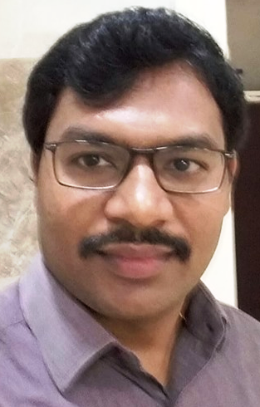
Mr. Tambi Medabala, Jr. Scientific Officer, Department of Physiology, Faculty of Sports Sciences, Sports Authority of India, Netaji Subhas National Institute of Sports, Patiala, India.

