details for website pa.com
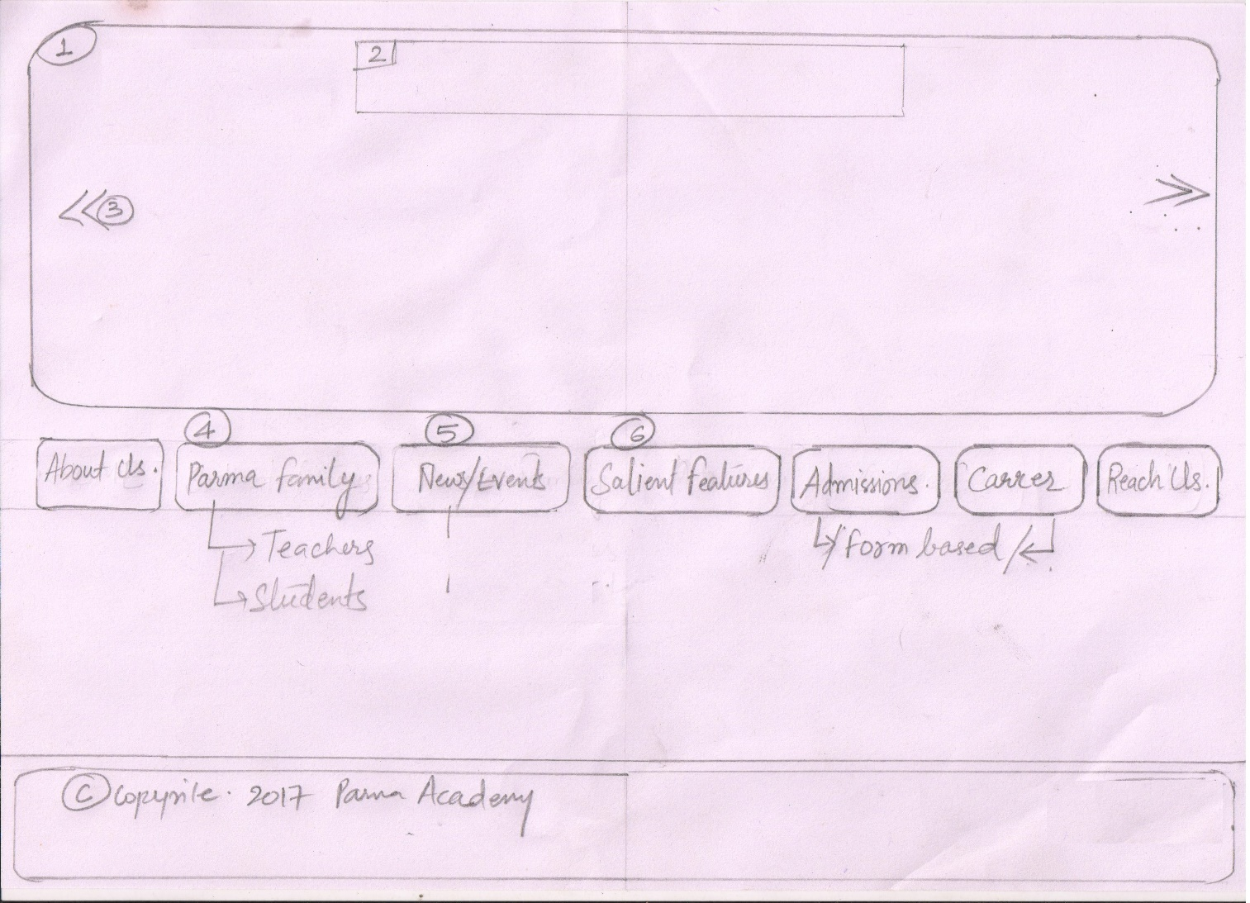

Points/Tabs | Description
1 and 3 | - Has auto scrollable (7) images  - Upper portion has to have the company name, logo and title.
2 | - Has Institute’s name, tag line and logo.
Login | - Only username password that has to be created will be of Admin
About US | - Auto scrollable messages  <No Image> Mission and Vision <message>  <Image 1> <message 1>  <Image 2> <message 2>  <Image 3> <message 3>  <Image 4> <message 4>  <Image 5> <message 5>  <Image 6> <message 6>
4. Parma Family | - Has a hover drop-down  - Teachers  - Students  - Can be edited updated by admin (Discussion required)
5. News/Events | - New/Events  - Latest News/Calendar
6. Salient Features | - Will be privided
Admission  (Form)  user will fill up the form and submit, details of which has to be mailed to an email id. | Let us contact you:  - Name (Textbox):  - Permanent Address:  - Contact No:  Fill Admission form online (Expandable form)  - Class to which admission is required:  - Name of child:  - Date of birth: (Date Calendar)  - Name of father:  - Permanent address:  - Occupation:  - Office address:  - Phone no.:  - Previous school of Child:  #Required Documents (Carry-in these documents at the time of admission)  - Photocopy of Aadhar Card  - Birth Certificate  - Three passport size photo  - T.C.(ORIGINAL)  - B.P.L. (Certificate, if needed)
Career  (Form)  user will fill up the form and submit, details of which has to be mailed to an email id. | - Title: (Mr./Ms./Mrs.) /drop-down/  - Name:  - Date of Birth: (Date Calendar)  - Post: (Principal, Vice-Principle, Teacher, Computer Operator, Accountant, Driver, Gardener) /drop-down/  - if (post==teacher)  - check-box list of subjects will appear  - Math  - Hindi  - English  - Science  - Social Studies  - G.K.  - Chemistry  - Biology  - Physics  - Physical Education  - Present employment:  - Years of experience:  - Qualification:  - Permanent Address:  - Phone No.:  #Required Documents (at the time of interview)  - Photocopy of Aadhar Card  - Original Certificates  - Three passport size photographs
Reach Us | - Will have Google Map location  - Facebook page  - Google+ page  - Phone/email

For Tabs horizontal/vertical is definitely an option
All backgrounds have to be school related materials like board/chalk/color pencils etc.
© nameOfInstitute & Year

